**Leader Overview**

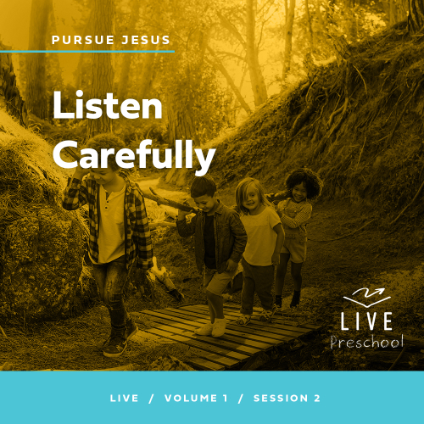

**Volume Overview**

**Pursue Jesus**

*Jesus’ offer is remarkably clear: If we look for Jesus, we’ll find Him. He’s not hiding from us, but closely connecting with Him does take us being intentional. We’re called to follow Him, to pursue Him. In this volume, we’ll look at how individuals pursued Jesus through the challenges of their circumstances. Pursuing Jesus is not only a mental exercise for personal growth, but it also means living out our faith in tangible ways: showing up, listening carefully, receiving grace, and trusting Him.*

**Session Overview**

**Listen Carefully**

*In this* **Live** *session, preschoolers will explore the conversation Nicodemus had with Jesus one night. Nicodemus was a Jewish leader and a Pharisee, but he wanted to know more about Jesus. So, he found an opportunity to go and listen to Him. We can always listen to Jesus, too.*

**Bible Lesson**

Nicodemus Seeks Jesus for Answers

[John 3:1–21](https://ref.ly/logosref/Bible.Jn3.1-21)

**Faith Fact**

I can always listen to Jesus.

**Faith Verse**

[Jeremiah 29:13](https://ref.ly/logosref/Bible.Je29.13) (NLT)

“If you look for me wholeheartedly, you will find me.”

**Preparing for the Session**

**Leader Preparation Time: 20–25 Minutes**

|  |
| --- |
| ***You Will Need***  ***Preservice Activities***  *• Toys*  *• Object for hiding in Bible Story Warm-Up*  *• Small paper plates, one per kid*  *• Red licorice whips (Twizzlers), one for every two kids*  *• Graham crackers*  *• Frosting*  *• Spoon*  ***Large Group***  *• Bible*  *• Worship songs (Song suggestions: “Whoa, I Have Life” by Yancy and Little Praise Party; “Superhero” by Hillsong Kids; “What a Beautiful Name” Lyric Video by Hillsong Kids)*  *• For groups not using a phone or tablet only, add:*  *• Projector or TV*  *• Laptop*  *•* ***Faith Fact Sound*** *video (bell ringing)*  *•* ***Faith Fact Slide***  *•* ***Faith Verse Slide***  *•* ***Faith Verse Video***  *•* ***Bible Lesson Video A***  *•* ***Bible Lesson Video B***  ***Small Group***  *•* ***Small Group Activity Page****, one per kid*  *• Markers or crayons*  *• Black construction paper, one sheet per kid*  *• Optional: Small star stickers*  *• Aluminum foil in small pieces, either cut up or torn*  *• Glue or glue sticks*  *To access session content and videos from a computer, visit:* [***BibleEngagementProject.com/downloads***](https://bibleengagementproject.com/downloads) |
| ***Getting Ready***  ***Preservice Activities***  *• Set out toys and snacks.*  *• Cut licorice whips in half, one half per kid.*  *• Break graham crackers in half to create squares, two squares per kid.*  *• Put a spoonful of frosting in a line on each plate, one plate per kid.*  *• Create a sample snack.*  ***Large Group***  *• Download videos and slides if needed.*  *• Select worship song(s) and have them ready to play.*  ***Small Group***  *• Print copies of the* ***Small Group Activity Page****, one per kid.*  *• Make a sample night sky.*  *• Optional: Cut moon shapes from foil, one per kid.*  ***First time leading* Live *for Preschool? Check out the*** [**Facilitator Guide**](https://0b769b0ed3569ef9d18b-f88d8272f61086866d50d048b43ef630.ssl.cf2.rackcdn.com/sites/biblengagementproject/Listen_Facilitator_Guide.pdf)***.*** |

**Preservice Activities**

*See what’s needed at the beginning of the session.*

**Bible Story Warm-Up**

Today, we’ll play a game. I’ve hidden an object in the room. It’s a ____ *(name object).* When I say, “Go.” you’ll work together to find it.

• *Tell kids if any part of the room is off limits.*

Are you ready? Go!

• *Celebrate when someone finds the object.*

• *If time allows, have the kids face a wall and close their eyes. Then, hide the object again.*

Was it hard to find the _____________ *(name object)*?

Would it have been easier to find if I had given you clues?

Who is someone you go to for help when you need to find something?

In the Bible story today, we’ll hear about a man who was looking for answers. He wanted to find out more about Jesus, so one night he went and talked with Jesus. Listen carefully and let’s see what we can learn about Jesus from this Bible story.

**Snack**

**Graham Cracker Book**

Today, we’ll focus on listening, so let’s practice as we make our snack. Let’s see if you can guess what we’re making.

• *Hand out the items to the kids.*

• *Demonstrate the steps as you do them.*

First, use your finger to smear frosting on one edge of each graham cracker. Now, take both of your graham crackers and stick them together so that they’re standing up together. Make sure one side of each cracker is touching the other with the frosting holding them together. Then, put your licorice between the two crackers to cover the frosting.

• *Help kids make the snack.*

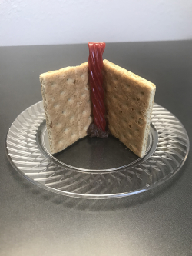

What did you make? *(Allow responses.)* You made some great books. Your books remind me of Bibles.

Can we always go to the Bible for answers?

If you can’t read, what is a great way to learn from the Bible?

In Bible times, people didn’t have Bibles like we do. They learned by listening to others who taught them, and only sometimes got to hear people read parts of the Bible. I can’t wait to see how the man in our Bible story finds the answers he was looking for. Make sure you listen carefully to learn more about Jesus.

**Free Play**

*Any extra time can be spent playing with toys.*

**Transition**

*A few minutes before service begins have kids make their way to the large group area and sit in their designated areas.*

**Large Group**

**25 Minutes**

*See what’s needed at the beginning of the session.*

**Introduction**

Hi, kids! It’s so good to be here with you today! We’ll have so much fun exploring the Bible together. *(Hold up Bible.)* Turn to the person sitting next to you and say, “I’m glad you’re here!” *(Group response)*

Today in our Bible story, there is a man who really wanted to talk to Jesus. We’ll find out how his talk went when he met Jesus. I’m glad we can talk to Jesus anytime. We never have to wait!

**Faith Fact**

I want to know Jesus more every day. Do you want that, too? *(Group response)* Then, that means we need to spend time with Jesus. We can read the Bible, and we can pray. But we also need to listen to Him. Hey, that’s our Faith Fact for today. **I can always listen to Jesus.**

• *Show the* ***Faith Fact Slide.***

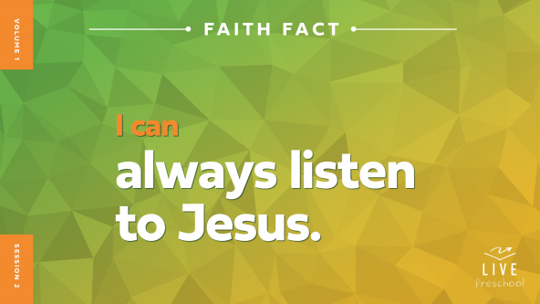

Let’s say our Faith Fact together. **I can always listen to Jesus.** Let’s use a little squeaky mouse voice to say it. **I can always listen to Jesus.** Now, use your leader voice to say it like you’re in charge. **I can always listen to Jesus.** Great job, everyone!

**Bible Time**

One of the most important places we can find out what Jesus wants us to know is in the Bible. I know our friend Lizzy has a Bible story for us today. On the count of three, let’s call, “Lizzy!” and see if she’s ready to talk with us. 1, 2, 3. Lizzy! *(Group response)*

• *Play* ***Bible Lesson Video A.***

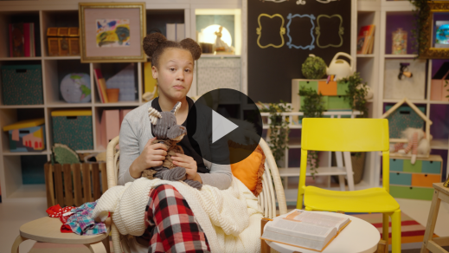

Did you hear what Lizzy wants us to do? *(Group response)* Let’s worship Jesus first, and then I’ll ask you what you think happens next in our Bible story.

**Worship**

Exploring the Bible is a great way to get to know Jesus. Now, let’s worship Jesus and praise Him together. As we worship, you can tell Jesus how much you love Him and thank Him for how good He has been to you. He is always listening.

**Praise**

Who wants to praise Jesus for stars that twinkle in the night sky? Wiggle your fingers to make the stars twinkle in the sky. *(Group response)*

Who wants to thank Jesus for always listening to us? Clap your hands. *(Group response)*

Who wants to thank Jesus for loving us? Wrap your arms around yourself and give a squeeze. *(Group response)*

**Sing**

I love when we praise Jesus and tell Him how much we love Him. Now, let’s worship Him by singing.

• *Lead the kids in singing one or two songs. See song suggestions at the beginning of the session.*

**Prayer**

Let’s pray together.

|  |
| --- |
| *Dear Jesus, You are so good to us. You made the stars, the moon, and so many more amazing things in this world. When we want to know You more, we can always listen to You. Thank You for loving us so much. Amen.* |

**Bible Time cont’d**

• *Begin* ***Bible Lesson Video B*** *and pause on the image of the two choices.*

Lizzy is coming back soon, so let’s put on our thinking caps. *(Demonstrate)* What do you think Nicodemus did next? Did he go to bed and put his head on his pillow? *(Point to “pillow” graphic.)* Or did he put on his shoes and go to find Jesus? *(Point to “sandals” graphic.)*

If you think Nicodemus just went to bed, put your hands next to your face like you’re sleeping. If you think Nicodemus went to Jesus even though it was nighttime, pretend to put on your shoes and move your feet like you’re walking. Ready? Choose your answer.

• *Pause while kids respond.*

Let’s find out if you’re right! Let’s check back in with Lizzy.

• *Play* ***Bible Lesson Video B.***

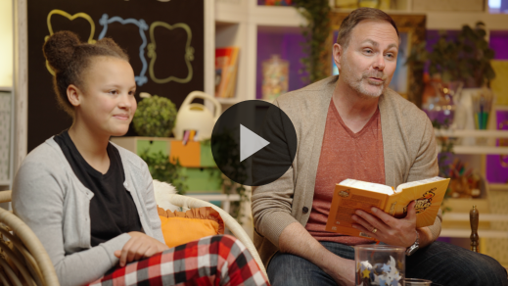

Wow! I’m so glad Nicodemus listened to Jesus and got the answers he needed. This Bible story teaches us that we can listen to Jesus, too.

**Response Time**

*Play a worship song quietly.*

Now, let’s respond to what we’ve learned today. Hold your hands out like this *(open palms)*. Let’s talk to Jesus. If you have a question for Jesus, you can ask Him. If you just want to know Jesus more, you can tell Him that. Sit quietly and listen for a few moments. Then, we’ll pray together.

• *Have the kids repeat phrases of the prayer after you.*

|  |
| --- |
| *Dear Jesus, thank You for the Bible and the wonderful truth I can find in it. Thank You that I can always ask You questions. I’m glad I can tell You exactly how I’m feeling. I want to know You more. I will listen to You. Amen.* |

**Faith Verse**

When we learn a Faith Verse, God can bring that verse back to our mind when we need it. Let’s say our Faith Verse and do the actions together.

[Jeremiah 29:13](https://ref.ly/logosref/Bible.Je29.13) (NLT)

“If you look for me wholeheartedly, you will find me.”

• *Show the* ***Faith Verse Video****.*

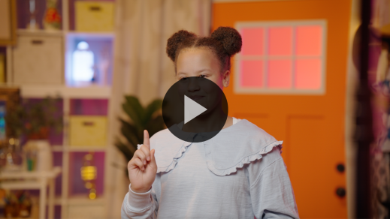

**Closing**

Wave your hands up high if you learned more about Jesus today. *(Group response)* We’ve worshipped Him with our singing voice and our praying heart. We’ve learned a Faith Verse from the Bible, and we know we can always talk to Jesus both during the day and at night.

• *Play the* ***Faith Fact Sound*** *video (bell ringing).*

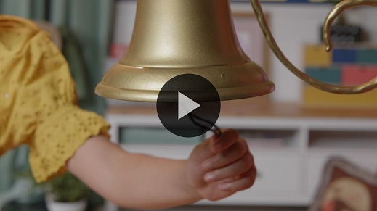

That sound means it’s time to say our Faith Fact one more time. **I can always listen to Jesus**.

• *Show the* ***Faith Fact Slide.***



Let’s shout it together. Ready? **I can always listen to Jesus.** Let’s say it as we walk in place like Nicodemus walked to see Jesus at night. *(Demonstrate the action.)* **I can always listen to Jesus.** Let’s whisper it so we don’t wake up anyone sleeping at night. **I can always listen to Jesus.**

**Dismissal to Small Groups**

That was so good! Now, we get to do some really special activities in our small groups.

• *Dismiss the kids by groups.*

|  |
| --- |
| ***Leader Tip:*** *This can be done by assigning color teams or by age groups. Note that some young preschoolers may not know their age. Using a colored sticker, jersey, or wristband will help separate the kids and help identify their small groups.* |

**Small Group**

**25 Minutes**

*See supplies and prep instructions at beginning of session or in each activity below.*

|  |
| --- |
| ***Leader Tip:*** *Small groups can alternate to each circle, or all groups can do each activity at the same time. If you choose to alternate, you will need at least one leader per circle.* |

**Circle 1**

**Group Connection**

**Long Distance Telephone Game**

Lizzy taught us a very special Faith Fact: **I can always listen to Jesus.** In our Bible story, Nicodemus listened carefully to Jesus, and we can, too.

As we play this game, we’ll have to listen carefully. Everyone needs to stand in a circle and hold hands with the person next to you. Now, let’s stretch out and make our circle as big as possible while still holding hands.

• *Give kids time to make a large circle.*

Now, drop your hands. Here’s how we’ll play. I will whisper a message to the friend next to me. That friend will hop to the next friend and whisper my message. We’ll go around the circle until the last friend hops to me and whispers the message to me. Finally, I’ll tell everyone what I heard. You’ll need to listen very carefully to pass the message all the way around our group.

• *Phrases to whisper to the kids:*

• Giraffes have long necks.

• I’d like to see a purple panda.

Those were some silly sentences! It’s so important to listen carefully, especially when we are learning about Jesus. Let’s play again. This time I’ll tell you things about Jesus.

• *Phrases to whisper to the kids:*

• Jesus loves everyone very much.

• I love Jesus. Do you love Jesus?

• (Faith Fact) **I can always listen to Jesus.**

Thanks for listening carefully, everyone!

**Circle 2**

**Activity Page Time**

**How Many Bibles?**

|  |
| --- |
| **You Will Need**  • **Small Group Activity Page**, one per kid  • Markers or crayons  **Getting Ready**  • Print copies of the **Small Group Activity Page**, one per kid. |

On your ***Activity Page***, there are several different objects. Let’s see how many Bibles you can find. When you see a Bible, circle it. When you think you have circled them all, count how many there are. Then, you can color the pictures.

• *Give kids time to find and count the Bibles.*

• *Optional: Count the Bibles together and show nonreaders which number to circle.*

You did a great job finding the Bibles. We can’t go and meet with Jesus like Nicodemus did, but one of the ways we listen to Jesus is by reading our Bible. When someone reads the Bible to you, listen carefully to see what Jesus is saying to you.

• *During the activity, interrupt and practice the Faith Fact:* **I can always listen to Jesus.**

• *Play the* ***Faith Fact Sound*** *video****.*** *Review the Faith Fact even if you can’t play the sound.*



**Circle 3**

**Feet-to-Floor Game Time**

**Red Light, Green Light**

Who remembers our Faith Fact? *(Group response)* Let’s say it together. **I can always listen to Jesus.** When we listen to Jesus, He can help us to know many things like when we should or shouldn’t do something.

Let’s play a fun game that helps us practice listening closely to someone. Who has played Red Light, Green Light? *(Group response)* In this game, when I say, “Green light,” you have to start moving around. When I say, “Red light,” you have to stop and freeze. If you don’t listen carefully when I say, “Red light,” you have to sit down while everyone else plays the next turn. Who is ready to play? *(Group response)*

• *Remind kids who move after you say, “Red light,” to be seated until the next turn.*

• *Let kids take turns being the leader.*

• *Play until you’re out of time.*

You did a great job listening during that game! It’s so important that we listen to Jesus. When we pray, we can talk to and listen to Him. We can read the Bible and learn from Him. I want to listen to Jesus. Do you want to listen to Him? *(Group response)*

**Circle 4**

**Hands-On Learning**

**Night Sky**

|  |
| --- |
| ***You Will Need***  *• Black construction paper, one sheet per kid*  *• Optional: Small star stickers*  *• Aluminum foil in small pieces, either cut up or torn*  *• Glue or glue sticks*  ***Getting Ready***  *• Make a sample night sky.*  *• Optional: Cut moon shapes from foil, one per kid.* |

Remember in our Bible story when Nicodemus went to see Jesus? What time of day was it? *(Allow responses.)* It was nighttime when Nicodemus talked to Jesus. I can only imagine the stars they could see in the sky. There weren’t big buildings and bright lights in houses like we have today, so they might have seen lots of stars in the sky that night.

Each of you will create a night sky like Nicodemus might have seen when he went to see Jesus. Everyone will get a piece of black paper to be your sky. You will also have some foil. You can use this to create your stars. You can scrunch up your foil to look like a star. Then, glue it onto your paper.

• *Demonstrate how to make stars.*

• *Give each kid a piece of black paper and foil.*

• *Optional: Give kids moon shapes or star stickers.*

• *Assist kids as needed.*

You did a great job making your night skies. They look great!

**Dismissal**

• *Play the* ***Faith Fact Sound*** *video (bell ringing).*



• *Show the* ***Faith Fact Slide.***



I had so much fun learning from the Bible with you today! Before we go, let’s say the Faith Fact together one last time. **I can always listen to Jesus.** Great job! See you next time!

• *Send home the* ***Small Group Activity Page*** *and the Hands-On Learning craft page with each kid.*

• *Remind parents that there are* ***Family Devotions*** *available on the app to do with their kid.*

• *Tell everyone the date and time for the next session.*